Software Requirements Specification

for

Online Pharmacy System

**Table of Contents**

1 Introduction 4

1.1 Purpose 4

1.2 Scope 4

1.3 Definitions 4

1.4 References 4

1.5 Overview 5

2 Overall Description 5

2.1 Product Perspective 5

2.2 Product Functions 6

2.3 Use Case Descriptions 6

2.4 User Characteristics 8

2.5 Constraints 8

3 Specific Requirements 8

3.1 Overview 8

3.2 Interface Requirements 8

3.3 System Features 9

3.4 Performance Requirements 12

3.5 Design Constraints 12

3.6 Software System Attributes 12

3.7 Other Requirements 13

# Introduction

## Purpose

This Software Requirements Specification (SRS) is intended to delineate software requirements for the customer’s gas pump system. This SRS is intended to provide guidance to the developers of the system to implement required functionality, as well as the test team to develop appropriate Verification and Validation (V&V) plans and procedures required to demonstrate to the customer that the system was built to this specification.

## Scope

This document specifies the requirements for the following capabilities.

1. User and Admin Registration
2. Product Catalog
3. Product Details and Reviews
4. Prescription Management

## Definitions

# 2. Overall Description

## 2.1 Product Perspective

An Online Pharmacy Web Application represents a crucial step toward enhancing the accessibility and efficiency of pharmaceutical services. This project aims to develop a user-friendly, secure, and efficient platform that enables users to purchase medications online, and access pharmaceutical information, thus bridging the gap between patients and healthcare services

In constructing our Online Pharmacy Web Application, we will implement Object-Oriented Programming (OOP) principles for a streamlined and scalable architecture. Classes will be employed to modularize entities and functionalities, enhancing code organization. Inheritance ensures code reuse, while encapsulation maintains data integrity. Polymorphism provides adaptability, and abstraction guides consistent implementations. By adopting these OOP concepts, we aim to develop a robust, user-friendly online pharmacy platform, seamlessly connecting patients with pharmaceutical services and healthcare professionals.

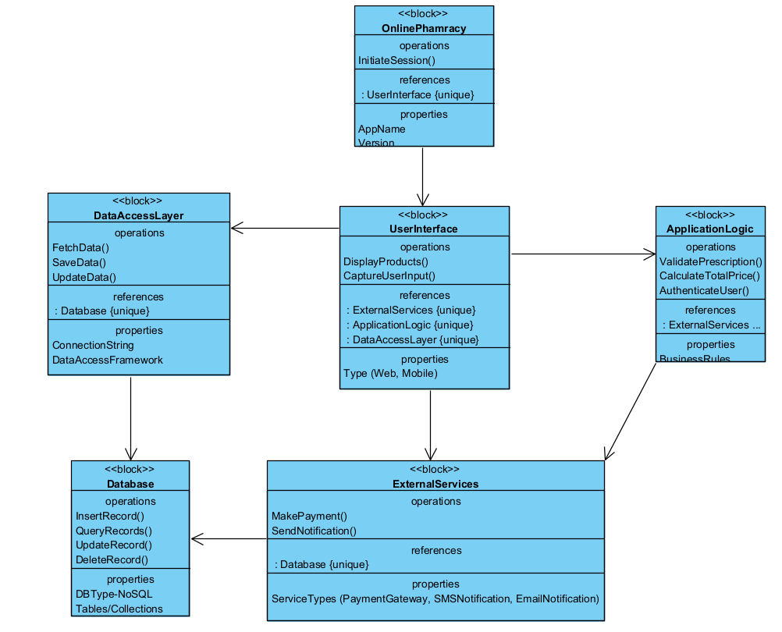

Figure 1 System Architecture Diagram

## 2.2Product Functions

The following use case diagram depicts the users of the system, and the intended way in which they will interact with the system.

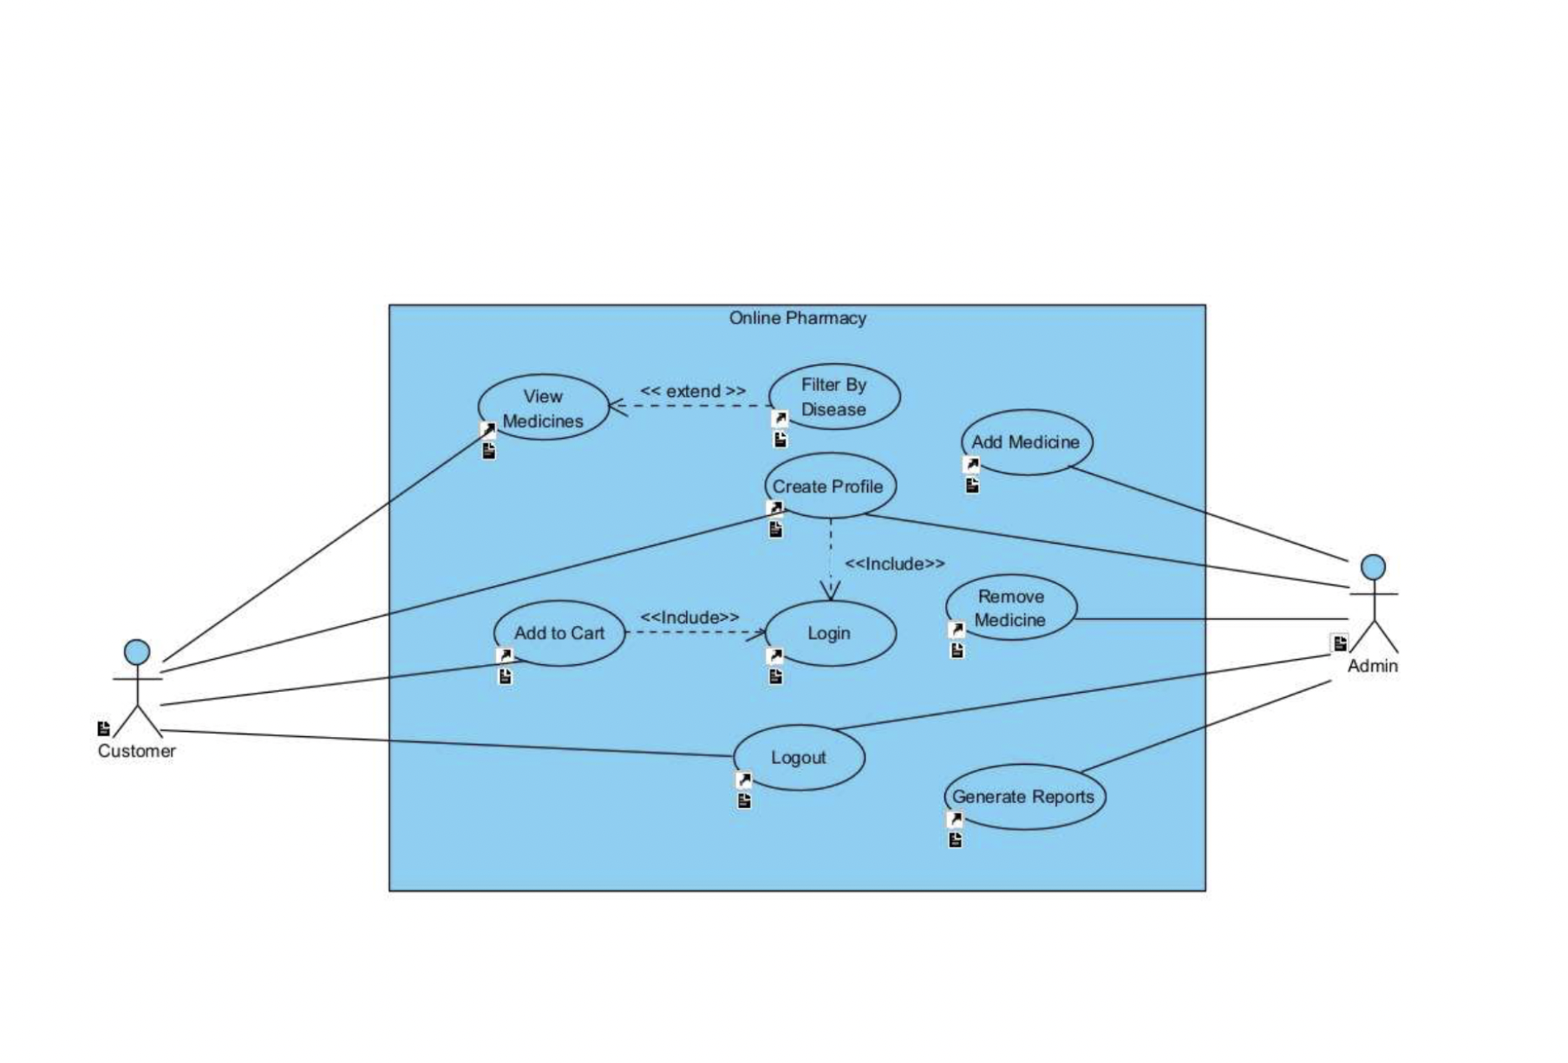

Pharmacy System Use Cases

Use Case Descriptions

2.3.1 User Registration

GENERAL CHARACTERISTICS

- Intent: Allow new customers to register, gaining access to pharmacy services.

- Scope: Online Pharmacy Web Application

- Primary Actor: Potential Customer

- Secondary Actors: Database, Email Verification System

- Preconditions: Potential customer requires internet access and the applications registration page.

- Assumptions: The system's database is ready for new registrations.

- Trigger: Selection of "Register" or "Sign Up".

Success Post Condition: Customer account creation and verification, providing access to the application.

Failed Post Condition: Failure in account creation due to data validation errors or system issues.

Sunny Day Scenario

1. Start: Prospective customer selects "Sign Up".

2. Action: Completes the registration form with personal details.

3. System Response: Validates and creates account, sends verification email.

4. Outcome: Customer verifies email, activates account.

5. End: Redirected to login screen.

Rainy Day Scenario

1. Start: Customer faces registration issues.

2. Action: System provides error messages.

3. System Response: Customer corrects data or seeks support.

4. Outcome: Customer either successfully registers or exits the process.

5. End: Use case ends after successful registration or withdrawal.

# 3. Specific Requirements

**User Registration and Management**

* Users can create and manage their accounts.
* Different user roles (e.g., customers, admin).

**Product Management**

* Ability to add, update, delete, and search for medications and health products.
* Display product details, including price, description, and availability.

**Ordering and Checkout Process**

* Users can add products to their cart and proceed to checkout.
* Integration of payment gateway for processing payments.

**Order Tracking and Management**

* Users can view their order history and track current orders.
* Pharmacists and admins can manage orders, update statuses, and process returns.

**Non-Functional Requirements**

**Security**

* Secure handling of personal and payment information.
* Compliance with healthcare and data protection regulations).

**Performance**

* Fast loading times and efficient processing of requests.
* Scalability to handle high volumes of users and transactions.

**Usability**

* Intuitive and user-friendly interface.
* Accessible on various devices (responsive design).

**Reliability and Availability**

* High uptime and minimal downtime.
* Backup and recovery mechanisms in place.

**Advanced Functional Requirements**

**Advanced Search and Filter Option**

* Ability to search for medications by name, category, active ingredient, or manufacturer.
* Filtering options based on price, brand, form (e.g., tablet, liquid), and dosage.

**Dynamic Pricing and Discounts**

* System to offer discounts, coupons, and promotional prices.
* Dynamic pricing based on demand, availability, or customer loyalty.

**Health Information and Resources**

* Provision of detailed drug information, usage instructions, side effects, and contraindications.

**Review and Ratings**

1. Feature for customers to review and rate products and services.
2. Display customer feedback and ratings on product pages.
3. The ability for users to manage their health profiles, including medical history, allergies, and chronic conditions.

Interface Requirements

User Interface Requirements

- Ull: Intuitive navigation for viewing and filtering medications.

- UI2: Profile creation process with step-by-step guidance.

- UI3: Simple login procedure with secure credential management.

- UI4: Visible and accessible logout option.

- UI5: Administrative capabilities to manage medication inventory.

- UI6: Reporting tools for admins with customizable parameters.

- UI7: Distinctive access controls for customers and admin roles.

Hardware and Software Interface Requirements

- HW1: Compatibility with standard web browsers on various devices.

- SW1: Integration with a backend SQL database.

- SW2: Secure API connections for payment processing and other services.

System Features

- SF1: 'View Medicines' functionality with advanced filtering options.

- SF2: Real-time shopping cart updates and management features.

- SF3: Administrative features for adding and removing medications.

- SF4: Comprehensive report generation for business analytics.

Specific Requirements

- REQ1: Medication browsing with multiple filters like disease, brand, and cost.

- REQ2: User profile management for order tracking and personal information updates.

- REQ3: Encrypted login process for user security.

- REQ4: Cart functionality with preview before purchase.

REQ5: Multiple secure payment options.

- REQ6: Admin controls for user account management and moderation.

- REQ7: Product listing management with the ability to update inventory.

- REQ8: Dynamic reporting tools for sales, inventory, and user engagement metrics.

- REQ9: Auto-logout for inactive sessions.

- REQ10: Compliance with data protection and privacy laws.